Signals are functions of independent variables that carry informations

Signals information in our daily life include

* speech, music, data, images, and video signals

More specifically,

* Stock price
* Voltage and current in a circuit
* Temperature
* Gene sequence
* Pressure
* Vibration

Independent Variable

* Continuous: analog audio signal that you can record over the microphone, position trajectory of a robot autonomous systems or UAVs or drones, temperature distribution in a room
* Discrete: digital audio signal, DNA sequence, image pixel
* There may 1, 2, or multiple independent variables (frequency, space, …)
* In this course, we will only deal with signals with one independent variable, called time.
  + Continuous Time Signal: x(t), t is a real number
  + Discrete Time signal: x[n], n is an integer

Continuous (a) vs. Discrete-time (b) signals

a 🡪 continuous time signal which is recorded over 32 ms period of time, can be your voice

b 🡪 after discretization, signal is converted to discrete time signals

Signal Types by Areas

* Audio signals
  + processed according to methodology then you can transfer your audio signals from one point to another
* Control signals
  + You can control Drone, UAV, Vacuum Cleaner Robot, TV through remote control etc. by sending control signals
* Graphics/Imaging signals
  + Used a lot in smartphone or TVs. Obtained through the cameras and process these image signals and display in different platforms.
* Medical signals
  + MR, Tomography…
* Communications signals
  + Used in order to access to internet using the Wi-Fi, GSM, 3G, 5G, GPS…
* Instrumentation signals
* Military signals
  + Radar signals, jam, …
* Telecom signals
  + GSM, 3G, …

What is System?

Systems transform input signals to output signals.

If the signals involved are discrete, the system is called a discrete time system.

If the signals involved are continuous, the system is called a continuous time system.

Both discrete and continuous time systems may be involved in a system (e.g., analog-to-digital conversion in sampling or digital-to-analog conversion in signal reconstruction)

H: Impulse response of a system in time domain.

We shape input u according to H and give output y. This is main objective of a system.

It is such as make different things to iron and give it a different shape as chair, table, etc.

Examples of Systems

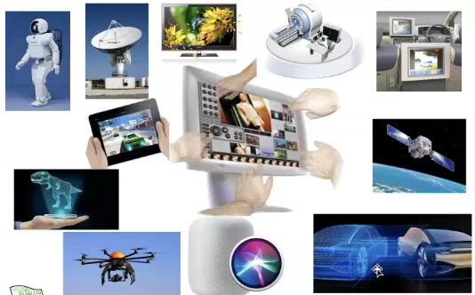

* A circuit (e.g., amplifier) with voltage input and current output.
* A motor with current input and torque as output.
* Noise removal audio filter (e.g., Dolby sound) with noisy audio signal as input and cleaned audio signal as output
* Stock price prediction (past stock history as input, predicted stock price as output).
* Edge detection algorithm for an image (raw image as input, processed image as output).

This course will cover the mathematical description of signals and systems, and their interaction.

Examples: Digital Audio

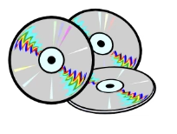Standard music CD:

* Sampling Rate: 44.1 kHz
  + Converting to discrete time signal
* 16-bit samples
  + Each sample is represented by 16 bits
* 2-channel stereo
* Data transfer rate = 2x16x44,100 = 1.4 Mbits/s
* 1 hour of music = 1.4x3,600 = 635 MB

Examples: Cell Phone

DSP: Digital Signal Processing

Example: VoIP

Example: Portable Media Devices

Gone because they are embedded in smartphones.

They are a lot of subsystems.